**PBJ Sandwich Documentation**

**Target Audience**：People trying to make a home-made traditional PBJ sandwich without any experience

**Tools and Material needed:** two slices of bread, peanut butter, jam, a clean knife, a clean teaspoon, a clean plate and toaster (optional)

**Instruction:**

**Step 1: Prepare the tools and materials mentioned above.**

There is no standard for bread, peanut butter and jam. Just pick an appropriate one for your favor and health. However, the most commonly used are strawberry jam and whole wheat or white bread for PBJ sandwich.

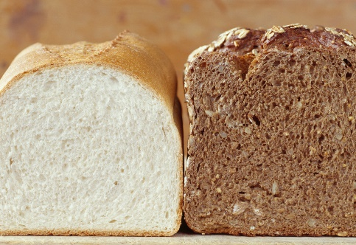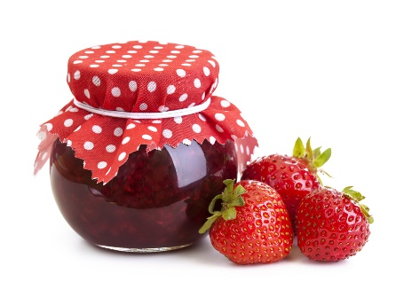

**Step 2: Toast your bread if you have a toaster.**

Toasting the bread definitely will give your sandwich more taste. However, it is still very delicious if you don’t have one.

**Step 3: Take one slice of bread onto a clean plate and spread peanut butter evenly onto it by using a knife.**

You can decide how much peanut butter you wish, but don’t do much more onto bread. If you just take the peanut butter from refrigerator, you could put some of the peanut butter in a bowl and microwave it for about 15 seconds. It will make much easier to spread evenly on the bread. 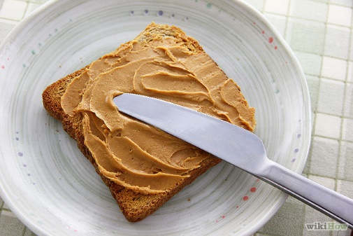

**Step 4: Take another slice of bread and apply jam evenly onto it by using a teaspoon.**

Using a teaspoon to measure how much jam wish and apply evenly onto the bread. Again, don’t do a lot of jam on the bread, otherwise it will get everywhere before you ready to eat it.

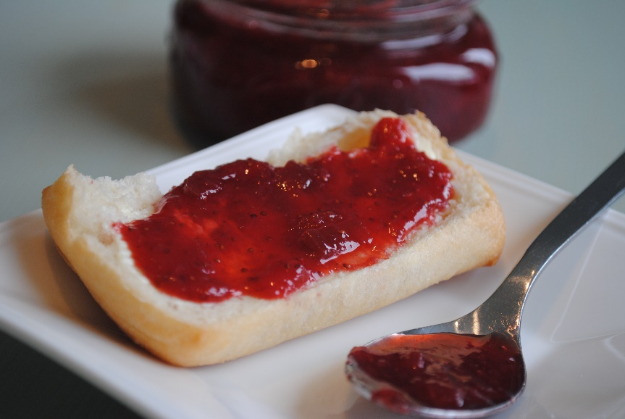

**Step 5： Combine both slices of bread.**

Keep in mind that do this quickly to avoid making jam and peanut butter everywhere.

**Step 6: Clean up the tools and store the materials you just used**

Don’t forget cleaning up and storing the materials in an appropriate place. It will be much helper and better for next time you make PBJ sandwich.

**Contact Information:**

**Yue Liu**

**liu2368@umd.edu**

**Time updated: 10/24/2016**

Word count: 317